*Tactile Navigation Support for Blind Individuals*

M Joshika

Computer Science and Engineering

Srinivasa Ramanujan Institute of Technology

Anantapur, India

<204g1a0545@srit.ac.in>

K Hemanth Reddy

Computer Science and Engineering

Srinivasa Ramanujan Institute of Technology

Anantapur, India

<214g5a0506@srit.ac.in>

H Arshia Parveen

Computer Science and Engineering

Srinivasa Ramanujan Institute of Technology

Anantapur, India

<204g1a0515@srit.ac.in>

G Akshaya

Computer Science and Engineering

Srinivasa Ramanujan Institute of Technology

Anantapur, India

<214g5a0501@srit.ac.in>

*Abstract*:

Sighted individuals possess the ability to navigate their surroundings with ease and utilize their visual facility to promptly identify potential hazards. Conversely, individuals who are visually impaired are unable to perceive the external environment, traverse independently, or discern danger. Moreover, they may occasionally feel distressed and wish to notify their family or friends of their location via text. So, the primary challenge faced by visually impaired individuals is their reliance on others, as even their closest relatives may not always be able to provide adequate care. To address this issue, "Smart Stick" would be developed utilizing the "Internet of Things". Using a variety of sensors, including ultrasonic, soil moisture, RF, GPS, and GSM modules and using Arduino UNO, the Smart Stick empowers blind people to be self-adequate and gives them sense of normalcy.

Keywords: Smart Stick, Ultrasonic Sensor, Soil Moisture, Solar Panel, Infrared Sensor, GPS-GMS Module, Relay Module, RF Module, User setup Notification.

# **Introduction**

Individuals who are visually impaired have several challenges in their daily lives, including those related to social interaction, movement, and information retrieval. Their freedom and quality of life may be impacted by these challenges. According to the World Health Organization (WHO) estimates that the number of people with visual impairment is 285 million (65% of whom are aged over 50 years). Of these, 246 million have low vision and 39 million are estimated to be blind. It has been estimated that over 80% of global visual impairment is preventable or treatable. Those with vision impairments find it difficult to navigate since they are unable to recognize potential dangers or obstacles. Their capacity to engage in daily tasks may be restricted and traveling outside the home may become difficult as a result. Furthermore, information access may be challenging for those who are visually challenged, especially if the material is presented in a visual style. It may also be more difficult for them to interact with the outside world and to read books, newspapers, or signs as a result.

The need for assistive technologies that might make it easier and more independent for visually impaired people to navigate the world is critical given the difficulties they experience. One such piece of technology that could make a positive impact on the lives of visually impaired people is the Smart stick, which offers improved information access, mobility, and navigation.

# **LITERATURE SURVEY**

The literature review section provides an overview of prior research and findings related to wet/damp surfaces, object detection, upstairs detection, and the Internet of Things (IoT). This survey seeks to contextualize the state of the field as it is today to close knowledge gaps and establish the foundation for the recommended technique.

## **Deveploment of an Ultrasonic sensor based walking aid**

This paper describes the creation of a walking stick with an ultrasonic obstacle detection sensor for those with vision impairments. The central processing unit (CPU) of the system is a PIC microcontroller, which sounds a buzzer to warn the visually impaired user to impediments that are identified within a 5 to 35 cm range [1]. Although the technology makes it easier to navigate safely in a variety of locations, it has trouble recognizing some barriers, such stairs and wet surfaces [5]. The study emphasizes the usefulness of the suggested walking stick while pointing out areas that might be improved in subsequent iterations to solve its present shortcomings.

## **Exploring Visionary Walking Aids: Focus on Water Surface Detection**

A unique walking assistance system for the visually handicapped is presented in this study. It combines a voice module, an ultrasonic sensor, soil moisture sensor, object, and water sensors, and a blind stick framework [2]. The Arduino UNO receives input from the ultrasonic sensor about obstacles and processes it. The Arduino UNO calculates the obstacle's proximity after analyzing the data. Nothing is done if there is not a barrier to the circuit closing [6]. But the Arduino UNO sounds a voice alert if the obstruction is nearby. Most notably, when obstacles are detected within 50 cm of the device, a single voice alert is generated by the system. The study focuses on the technology design and operation of the developed walking aid device for visually impaired individuals [7].

## **GPS-Based Stick Localization: Challenges and Constraints**

To pinpoint an object's accurate ground position smart stick, to be exact, this paper describes the use of the GPS as a satellite navigation system [3]. The stick's location data is updated to a central main board through this system. It is crucial to remember, nevertheless, that this system's effectiveness is limited indoors because GPS signals are unavailable there [4]. Additionally, signals are only precise within 5-meter range, indicating limits in the technology. Under some operational scenarios, the study emphasizes the intrinsic limitations of GPS-based positioning systems [8].

## **RF-Based Stick Localization for Visually Impaired Autonomy**

If the stick is misplaced from its intended location, visually challenged people can be informed of its whereabouts by activating RF remote control device. The remote control may send signals to the stick thanks to the RF modules, which enable wireless communication. By providing a concrete method of directing visually impaired individuals back to the proper location of the stick, this communication increases their independence and reduces the possibility of misplacing. To create a dependable and effective localization system for assistive sticks intended for people with vision impairments, RF technology must be integrated.

# **OBJECTIVE**

The main objective is to develop a comprehensive model geared towards enabling autonomous navigation for individuals with visual impairment in diverse environments, encompassing both familiar and unfamiliar locales. The implementation includes an alert system utilizing a buzzer to effectively signal the presence of obstacles, facilitating obstacle detection and avoidance. Additionally, the project focuses on the creation of a user-friendly interface featuring tactile feedback and discernible sensations specifically tailored for blind users. The intent is to provide a nuanced and accessible interface, allowing blind individuals to interpret environmental cues and navigate with enhanced self-sufficiency.

# **PROPOSED SYSTEM**

The proposed system is capable of detecting the surroundings for various barriers of different sizes and producing the required auditory using the ultrasonic sensor in the presence of buzzer. When damp surfaces are detected using sensors, it might alert the user by vibratory sounds and also enable to send SMS based on the user's location in an emergency or when they are having trouble. When the stick is misplaced, the user can find the stick by using RF remote control.

**Block Diagram**

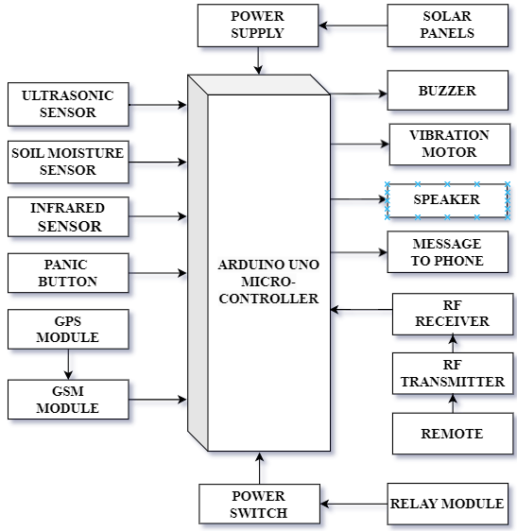

**Fig-1: Block Diagram of Proposed System**

# **METHODOLOGY**

### Developing a Smart stick comprising two modules: one for Object Detection & Wet surface Detection alerts the user by sending buzzer & vibration sounds and another for GMS and GPS Modules for sending location to mobile devices via Push button.

### **Module 1: Object and Wet Surface Detection**

### The first module utilizes ultrasonic sensors for object detection and soil moisture sensors for wet surface detection. Alerts the user through a dual-alert mechanism, comprising a buzzer for auditory signals and a vibration mechanism for tactile feedback.

### **Module 2: GSM and GPS Location Notification System**

### The second module incorporates GPS and GSM modules for accurate communication and position tracking. Actual-time location notifications are transmitted via push notifications to pre-specified mobile devices when user-initiated push button is pressed. Combines location-based communication with sophisticated environmental awareness to create absolute Smart Stick solution.

**Components**

## **Arduino UNO**

The Arduino UNO is a microcontroller board featuring the ATmega328P microcontroller. It encompasses 14 digital input/output pins, with 6 configurable as PWM outputs, and 6 analog inputs. The board is equipped with 16 MHz ceramic resonator, an USB connection for computer interfacing, a power jack, an ICSP header for in-circuit programming, and a reset button. It provides comprehensive support for the microcontroller, facilitating ease of use by connecting it to a computer via USB or powering it through an AC-to-DC adapter or a battery for seamless initiation of operations.

**Fig-2 Arduino Uno**

1. **Ultrasonic Sensor**

The ultrasonic sensor is an electronic transducer that gauges target distance by emitting ultrasonic waves. Utilizing piezoelectric crystals, the transmitter releases sound waves, which, upon reflecting off the target, are captured by the receiver. The received signals are then converted into electrical signals, enabling precise distance measurement. Notably, ultrasonic waves operate beyond the audible range of humans, with the sensor's core components are being the transmitter and receiver.

**Fig-3 Ultrasonic Sensor**

1. **Soil Moisture**

The soil moisture sensor functions as a device designed to quantify the volumetric water content present in the soil. Unlike the conventional gravimetric approach that involves the removal, drying, and weighing of soil samples, these sensors employ alternative methodologies. Measurement of volumetric water content is achieved indirectly, utilizing parameters such as dielectric constant, electrical resistance, or interactions with neutrons. These sensors rely on principles other than direct gravimetric measurements, providing more efficient and non-invasive means of assessing soil moisture content.

**Fig-4 Soil Moisture Sensor**

1. **Infrared Sensor**

An infrared sensor is an electronic device that detects infrared radiation, including movement and object heat. Operating as a sensitive photodiode in the non-visible spectrum, it undergoes resistance and voltage changes proportional to received infrared light intensity. Widely used for object presence detection, it is effective in identifying objects within a specified area.

**Fig-5 Infrared Sensor**

1. **RF module**

A RF module, or radio-frequency module, is a compact electronic device facilitating wireless communication between two devices through the transmission and reception of radio signals. This wireless exchange of information can be achieved through optical communication or, alternatively, through the utilization of radio-frequency (RF) communication. Widely used in embedded systems, RF modules play a crucial role in establishing efficient wireless connectivity, utilizing either optical or radio-frequency communication methods.

**Fig-6 RF Module**

1. **GSM Module**

The GSM module is integral for device communication with the GSM network, managing the establishment and upkeep of communication links. It plays a key role in emergency notifications, alerting designated recipients via SMS. Operational prerequisites include integration with a cellular network and SIM card.

**Fig-7 GSM Module**

1. **GPS Module**

GPS is a satellite-based navigation system delivering time and location data to GPS receivers. It operates in all weather conditions and is utilized to provide accurate location information, including latitude, longitude, altitude, and time, to devices like Arduino Uno via serial communication. It is instrumental in assisting visually impaired individuals by sharing precise location details with distressed parties.

**Fig-8 GPS Module**

1. **Relay Module**

A relay module is an electrical switch operated by an electromagnet, activated by a low-power signal from a microcontroller. It controls electrical circuits by opening or closing, comprising a coil, solenoid, iron yoke, movable armature, and contacts. Key components include a wire coil surrounding the solenoid, an iron yoke providing a low reluctance path for magnetic flux, a movable iron armature, and one or more sets of contacts.

**Fig-9 Relay Module**

1. **Batteries**

A battery is an energy storage device that converts chemical energy to electricity through electrochemical reactions. It consists of cells with three primary components: an anode ('-'), a cathode ('+'), and an electrolyte facilitating chemical reactions. Batteries serve as essential power sources in diverse applications, functioning by harnessing chemical potential energy and transforming it into electrical energy for utilization in electronic systems.

**Fig-10 Batteries**

1. **Speaker**

A speaker is employed as an auditory signaling component to deliver audio alerts to the user. The relay associated with the infrared sensor is configured to trigger upon detecting an obstruction, subsequently activating the speaker to emit alerting sound. This relay-driven mechanism ensures that the speaker is engaged in response to the infrared sensor's detection of an obstacle, providing effective means of alerting the user to the presence of obstructions in the monitored environment.

**Fig-11 Speaker**

1. **Vibration motor**

A vibratory motor, is deliberately unbalanced three-phase motor used for vibrating sieves and providing haptic feedback. Controlled by a relay triggered by a moisture sensor detecting water, the motor is activated to induce vibration in response to the detected moisture presence. The relay linked to the moisture sensor is then activated, facilitating the seamless integration of the vibratory motor into the system.

**Fig-12 Vibration Motor**

1. **Solar Panels**

A solar panel, utilizing photovoltaic cells, converts sunlight into electricity by exciting electrons. These electrons generate direct current (DC) electricity, suitable for powering devices or storing in batteries. The setup incorporates two 4V solar panels for a battery charging alongside a conventional power source. Solar technologies, employing mirrors or PV panels, harness solar energy for electricity production or storage in thermal storage or batteries.

**Fig-13 Solar Panels**

# **IMPLEMENTATION**

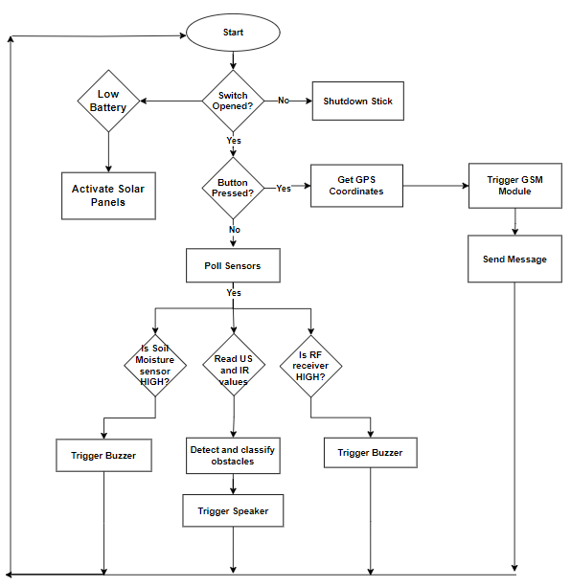

**Fig-14 Flow Chart**

# **RESULT**

The Circuit diagram for the while setup of the Smart Stick. It is capable of detecting the surroundings for various barriers of different sizes and producing the required auditory using the ultrasonic sensor in the presence of buzzer. When damp surfaces are detected using sensors, it might alert the user by vibratory sounds and also enable to send SMS based on the user's location in an emergency or when they are having trouble. When the stick is misplaced, the user can find the stick by using RF remote control.

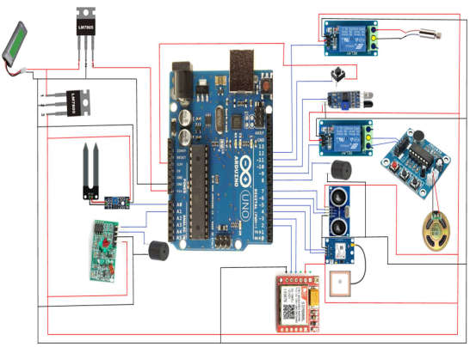

**Fig-15 Experimental Setup**

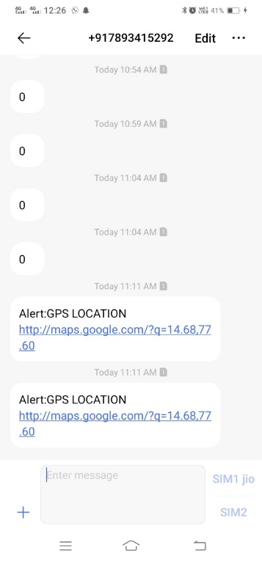

**Fig-12 Alert Messages to the Coordinates of the Blind**

**Person**

# **CONCLUSION**

Finally, the proposed system effectively detects barriers using the ultrasonic sensor with auditory alerts and provides safety features such as vibratory alerts for damp surfaces and emergency SMS based on user location. The inclusion of an RF remote control for stick retrieval enhances user autonomy. The system offers a comprehensive solution for obstacle detection, emergency response, and stick location retrieval, making it valuable tool for individuals with visual impairment.

# **FUTURE WORK**

The future scope for the multifunctional blind stick encompasses machine learning for adaptive obstacle detection, smart navigation for optimized routes, advanced communication with voice recognition, IoT connectivity, wearable technology exploration, user feedback mechanisms, improved indoor localization, adherence to global accessibility standards, community integration, and miniaturization for enhanced user adoption.

# **REFERENCES**

1. Naiwrita Dey, Ankita Paul, Pritha Ghosh, Chandrama Mukherjee, Rahul De,“Ultrasonic Sensor Based Smart Blind Stick”, International Conference on Current Trends toward Converging Technologies, Coimbatore, India, 978-1-5386-3702-9/18 2018.
2. Md.Adil, TaiyabaShadaka Rafa, Jannatul Ferdoush, Abir Mahmud, Abhijit Pathak, “An IoT based Voice Controlled Blind Stick to Guide Blind People”, International Journal of Engineering Inventions, Volume 9, Issue 1 Jan 2020.
3. Somnath koley, Ravi Mishra, ”Voice operated outdoor navigation system for visually impaired persons”, International Journal of Engineering Trends and Technology- Volume 3, Issue2- 2012.
4. Suraj Babhale, Pratiksha Bhagat, Nikhita Saharkar, Mayur Pillewan, Nikhil Rangari, V. N. Mahawadiwar, “Implementation of Smart Stick for Blind and Visually Impaired People using Arduino”, International Journal of Innovative Research in Science, Engineering and Technology, Volume 10, Issue 6, June 2021.
5. M. Ghana Shyam, Shravankumar G M, Ashabee, Kodal Ashwini, Ravi Kumar H M, ”Blind guide stick using GPS and GSM module”, International Research Journal of Engineering and Technology Volume 7, Issue 6, June 2020.
6. Ronak Panchal, Sneha Sankhe, Saad Khan, Vishal Singh, “Blind Stick for Visually Impaired People”, International Research Journal of Engineering and Technology Volume 8, Issue 5, May 2021.
7. Mohd Helmy Abd Wahab, Amirul A. Talib, Herdawatie A. Kadir, Ayob Johari, A.Noraziah, Roslina M. Sidek, Ariffin A. Mutalib, “Smart Cane: Assistive Cane for Visually-impaired People”, International Journal of Computer Science Issues, Vol. 8, July 2011.
8. R.Dhanuja, F.Farhana, G.Savitham “Smart Blind Stick Using Arduino”, International Research Journal of Engineering and Technology, Volume 5, Issue 3, March 2018.
9. Mukesh Prasad Agrawal, Atma Ram Gupta, “Smart Stick for the Blind and Visually Impaired People”, Proceedings of the 2nd International Conference on Inventive Communication and Computational Technologies (ICICCT 2018) IEEE Xplore Compliant - Part Number: CFP18BAC-ART; ISBN:978-1-5386-1974-2.
10. Deepasri. S, Prof. Sujatha. S, “Real Time Object Detection and Voice Assistance for Blind Using Tensorflow”, International Journal of Research Publication and Reviews, Vol 3, no 9, pp 52-55, September 2022.
11. Ankit Agarwal, Deepak Kumar, Abhishek Bhardwaj, “Ultrasonic Stick for Blind”, International Journal Of Engineering And Computer Science ISSN:2319-7242 Volume 4 Issue 4 April 2015.
12. Mohammed Azher Therib, “Smart Blinding Stick with Holes,Obstacles and Ponds Detector Based on Microcontroller”, Journal of Babylon University/Engineering Sciences/ No.(5)/ Vol.(25): 2017.
13. Ayat A. Nada, Mahmoud A. Fakhr, “Assistive Infrared Sensor Based Smart Stick for Blind People”, Science and Information Conference 2015 July 28-30, 2015.
14. Chaitra Mahantesh Lokannavar, Kavya CK, Kavya SM, Priya G R, Vijayananda V Madlur, “Iot Based Navigation System For Visually Impaired People”, Volume:05, Issue:05, May-2023.
15. Suraj Babhale, Pratiksha Bhagat, Nikhita Saharkar, Mayur Pillewan, Nikhil Rangari, V. N. Mahawadiwar, “Implementation of Smart Stick for Blind and Visually Impaired People using Arduino”, International Journal of Innovative Research in Science, Engineering and Technology, Volume 10, Issue 6, June 2021.